**MILESTONE AND ACTIVITY LIST**

Date

13 November 2022

Team ID

PNT2022TMID44470

Project Name

Project – SKILL\JOBS

RECOMMENDER APPLICATION

Maximum Marks

2 Marks

ProjectName

Date

13-11-2022

4

Skill\Jobs Recommender Application

PNT2022TMID44470

Team ID

Team Members

**Activity**

**Number**

**Activity Name**

**Detailed Activity Description**

**Assigned To**

**Status /**

**Comments**

**1**

**Preparation Phase** Access the resources (courses) in project dashboard

Access the guided project workspace

It refers to done

the listed activities

in the preparation

phase and done

Prerequisites,

Krishnan V

Mohamed arief M

Shabari G

Saravanan A

Create GitHub account & collaborate withProject

Repository in project workspace

Set-up the Laptop / Computers based on

the prerequisites for each technologytrack

Registration,

Environment setup



**2**

**Ideation Phase**

Literature survey on the selected project & Information

Gathering

Preparation of Empathy Map Canvas to capture the

user Pains & Gains, Prepare list of problem statements

Krishnan V

Mohamed arief M

Shabari G

Saravanan A

The activities in

ideation phase

refers to when

gathering the idea

for project

List the

ideas by

organizing the

brainstorming session and prioritize thetop 3 ideas

based on the feasibility & importance

information and

picturize in

Empathy map,

referring the

literature survey&

brain storming

the ideas for this

project.



**3**

**Project Design Phase -I**

3.1

ProposedSolution

Preparation of proposed solution document,which

includes the novelty, feasibility of idea,business

model, social impact, scalability of solution

The solution for the

project is prepared

asa standard

document

Krishnan V

structure

from Team

members

3.2

3.3

Problem Solution fit

Solution Architecture

Preparation of problem solution fit

Prepare an architecture for solution

Prepared problemis

analyzed and make

effective solutions

for the

Mohamed arief M

problem

Suitable block

diagram template

used to prepare

Solution

Shabari G

architecture

**4**

**Project Design Phase -II**

4.1

Requirement

Analysis

Prepare the Functional Requirement and Non-

Functional Document

Listing of

functional and

non- functional

requirements of

projects.

Krishnan V

Shabari G

4.2

Customer

Journey

Preparation of customer journey maps to

understand the user interactions & experiences

with the application (entry to exit)

Customer journey

map prepared by

suitable template by

team

members.

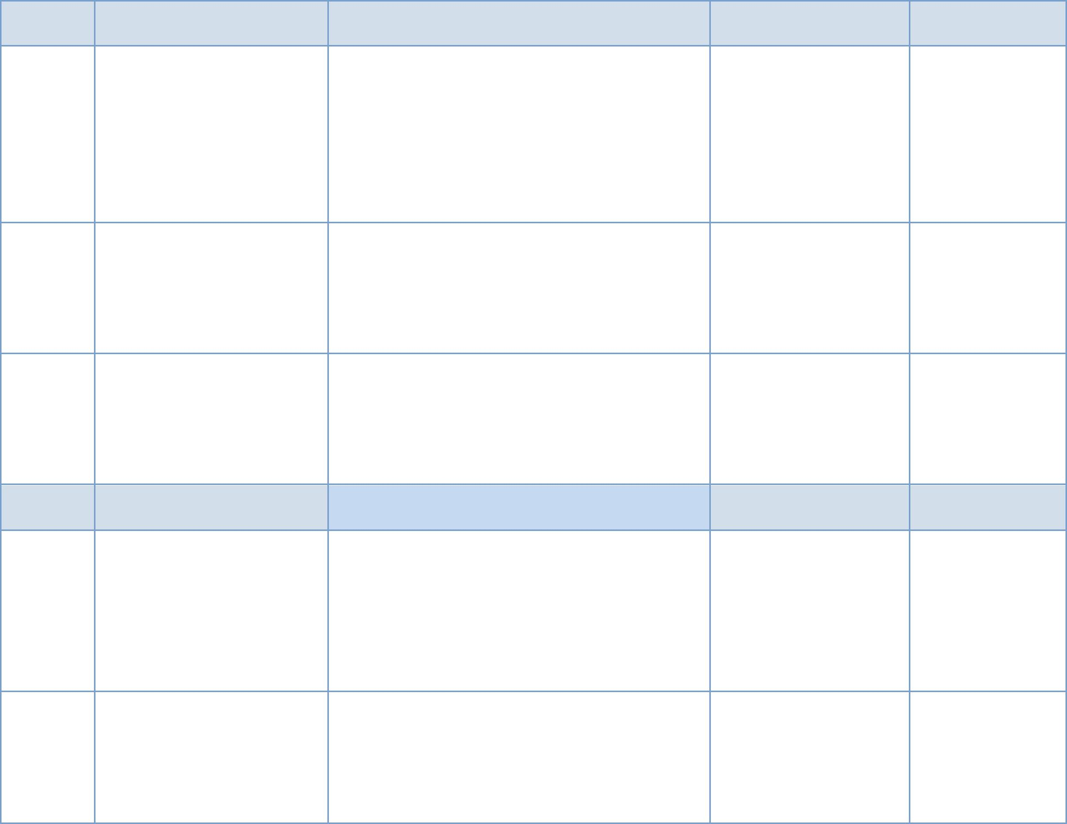

4.3

4.4

Data FlowDiagrams

Prepare a Data Flow Diagram for Project

Use suitable data

flow diagram rules

and standards to

prepare DFD

Mohamed arief M

Shabari G

Technology

Architecture

Prepare Technology Architecture of the solution

We created

architecture

diagram and

technologies used

for this project



**5**

**Project planning phase**

5.1

Milestones & Tasks

Prepare Milestone & Activity List

When project begins

then it is expected

that project related

activities must be

initiated. In project

planning, series of

milestones must be

established.

Shabari G

Krishnan V

5.2

Sprint Schedules

Prepare Sprint Delivery Plan

In this, Product

Backlog, Sprint

Mohamed arief M

Schedule for the

Project areestimated.

**6**

**Project Development**

**Phase**

6.1

6.2

Coding & Solutioning

AcceptanceTesting

Sprint-1 Delivery: Develop the Code, Test and push

it to GitHub.

Krishnan V

Mohamed arief M

Shabari G

Saravanan A

In progress

Sprint-2 Delivery: Develop the Code, Testand push

it to GitHub.

Sprint-3 Delivery: Develop the Code, Testand push it

to GitHub.

Krishnan V

Mohamed arief M

Shabari G

Saravanan A

In progress

In progress

6.3

PerformanceTesting

Sprint-4 Delivery: Develop the Code, Test andpush

it to GitHub.

Krishnan V

Mohamed arief M

Shabari G

Saravanan A

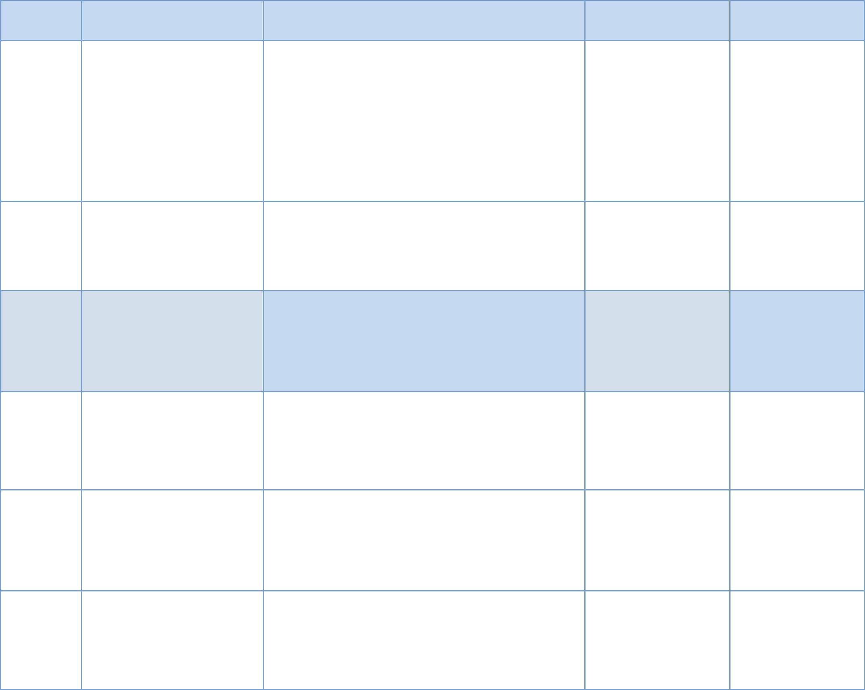

**Milestone:**

When project begins then it is expected that project related activities must be initiated. In project planning, series of milestones

must be established. Milestone can be defined as recognizable endpoint of software project activity. At each milestone, report must

be generated.

Milestone is distinct and logical stage of the project. It is used as signal post for project start and end date, need for external

review or input and for checking budget, submission of the deliverable, etc. It simply represents clear sequence of events that are

incrementally developed or build until project gets successfully completed. It is generally referred to as task with zero-time duration

because they are used to symbolize an achievement or point of time in project. It helps in signifying change or stage in

development.

